**A CRM Application to Manage the Booking of Co-Living**

**By**

**RAPELLI SAITEJA**

[Sai teja](mailto:rapellisaiteja999@gmail.com)

**Abstract: CRM Application for Co-Living Booking Management**

The **CRM Application for Co-Living Booking Management** is a comprehensive solution designed to facilitate efficient booking and management of co-living spaces. It caters to both co-living operators and residents, ensuring a seamless experience throughout the booking lifecycle.

**Key Features:**

1. **Room Types and Sharing Options**:
   * Users can choose from various room types, including single sharing, double sharing, and triple sharing.
   * Additionally, the application offers AC variants: single AC sharing, double AC sharing, and triple AC sharing.
   * Each room type is associated with specific amenities and pricing.
2. **Customer Management**:
   * The application maintains customer profiles, including personal details, preferences, and booking history.
   * Operators can efficiently handle customer inquiries, modifications, and cancellations.
3. **Room Booking and Availability**:
   * Residents can search for available rooms based on their preferences (e.g., sharing type, AC/non-AC).
   * Real-time availability updates ensure accurate booking information.
4. **Payment Integration**:
   * Secure payment gateways allow residents to make online payments for bookings.
   * Operators can track payment status and issue invoices.
5. **Food Selection**:
   * Residents can customize their stay by selecting meal plans (e.g., breakfast, lunch, dinner).
   * The application manages meal preferences and dietary restrictions.
6. **Feedback and Reviews**:
   * Residents can provide feedback on their experience, helping operators improve services.
   * Ratings and reviews contribute to overall customer satisfaction.

**Benefits:**

* **Efficiency**: Streamlined processes reduce manual effort and enhance operational efficiency.
* **Personalization**: Customizable options cater to individual preferences.
* **Revenue Optimization**: Real-time availability tracking and dynamic pricing contribute to revenue growth.

**Future Enhancements:**

* **Integration with IoT Devices**: Connecting smart devices (e.g., room temperature control, lighting) for enhanced resident comfort.
* **Predictive Analytics**: Leveraging historical data to predict demand patterns and optimize room allocation.

**INDEX PAGE**

**Topics Page no**

1.Developer Account Creation and 5-7

Activation

2.Object Creation 7-14

3.Tab Creation 14-18

4.Lightening App creation 19-20

5.Fields and Relationships 21-34

6.Create Validation Rules 35-36

7.Create Profiles 37-38

8.Create Roles 39

9.Create User 40-42

10.Create Reports 42-43

11.Create Dashboard 44-45

12.Create Flows 45-50

**INTRODUCTION**

**Task 1:** Developer Account Creation and Activation

### **Creating Developer Account**

Creating a developer org in salesforce.   
1. Go to <https://developer.salesforce.com/signup>  
2. On the sign up form, enter the following details :

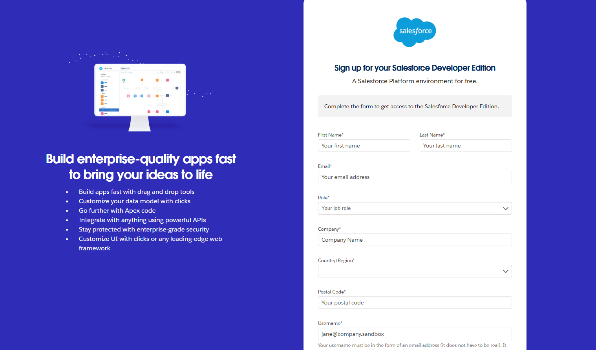

1.First name & Last name

2.Email

3.Role : Developer

4.Company : College Name

5.County : India

6.Postal Code : pin code

7.Username: username@organization.com

### Account Activation

1. Go to the inbox of the email that you used while signing up. Click on the verify account to activate your account. The email may take 5-10mins.

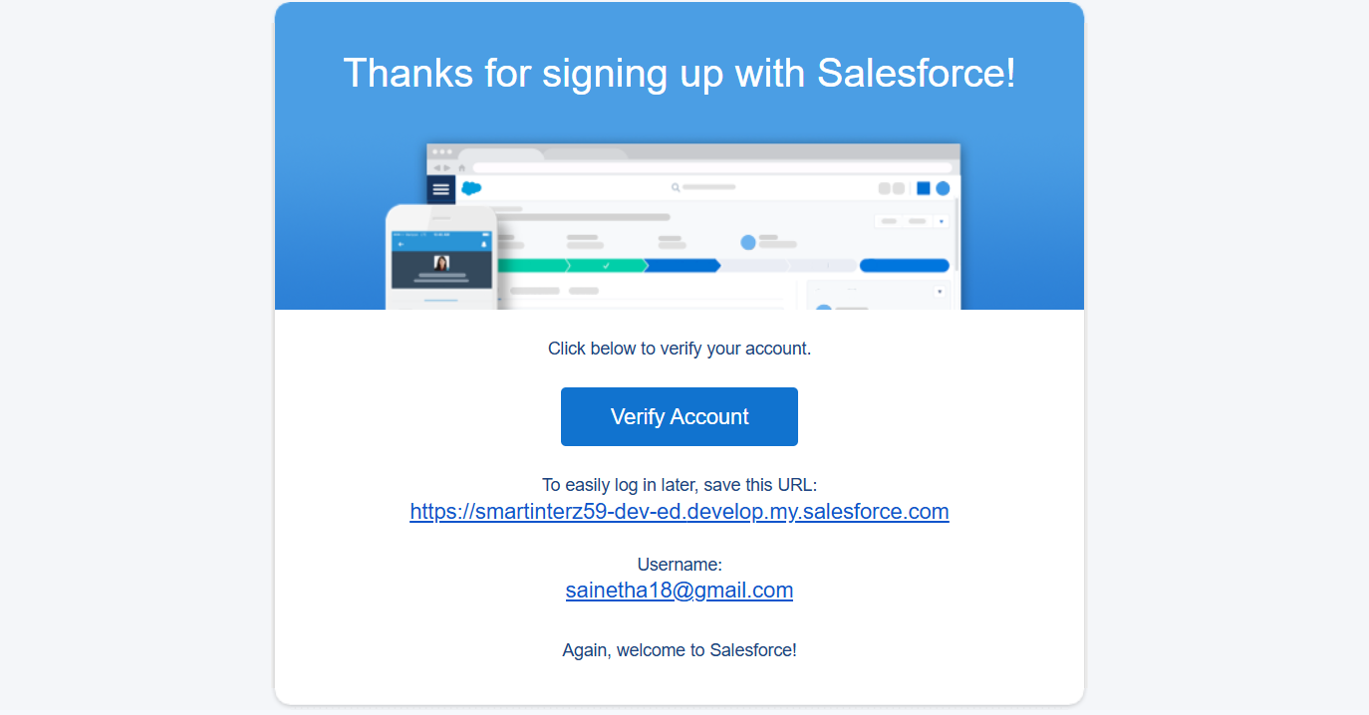

2. Click on Verify Account  
3. Give a password and answer a security question and click on change password.

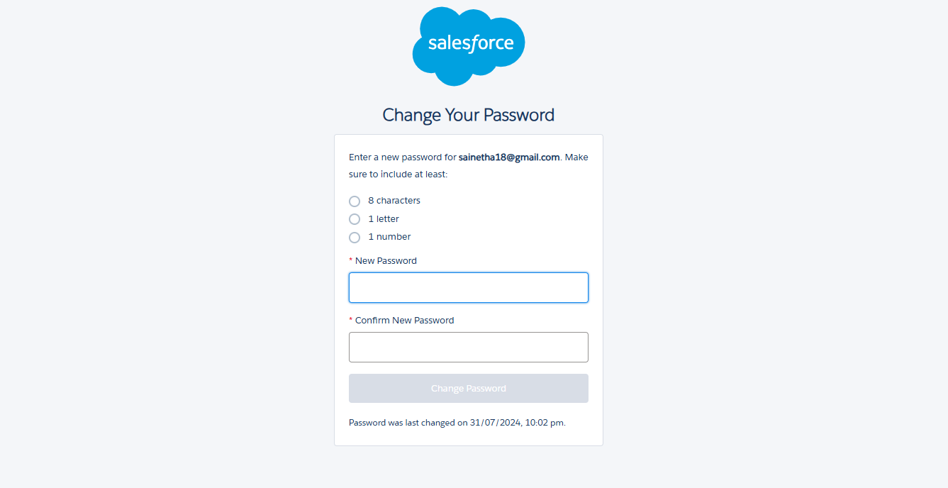

4. Then you will redirect to your salesforce setup page.

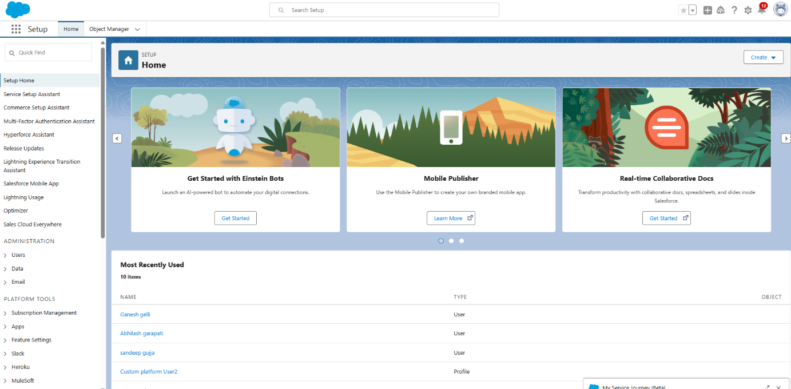

**Task 2:** Object Creation

**Create a custom object for Total Room:**

To create a custom object, follow these steps:  
1. From setup click on object manager.  
2. Click create, select custom object.

3. Fill in the label as " Total Room ".  
4. Fill in the plural label as " Total Rooms ".  
5. Record name: "Total No Of Rooms"  
6. Select the data type as "Text".  
7. In the Optional Features section, select Allow Reports and Track Field History.  
8. In the Deployment Status section, ensure Deployed is selected.  
9. In the Search Status section, select Allow Search.  
10. In the Object Creation Options section, select Add Notes and Attachments related list to default page layout.

11. Leave everything else as is, and click Save.

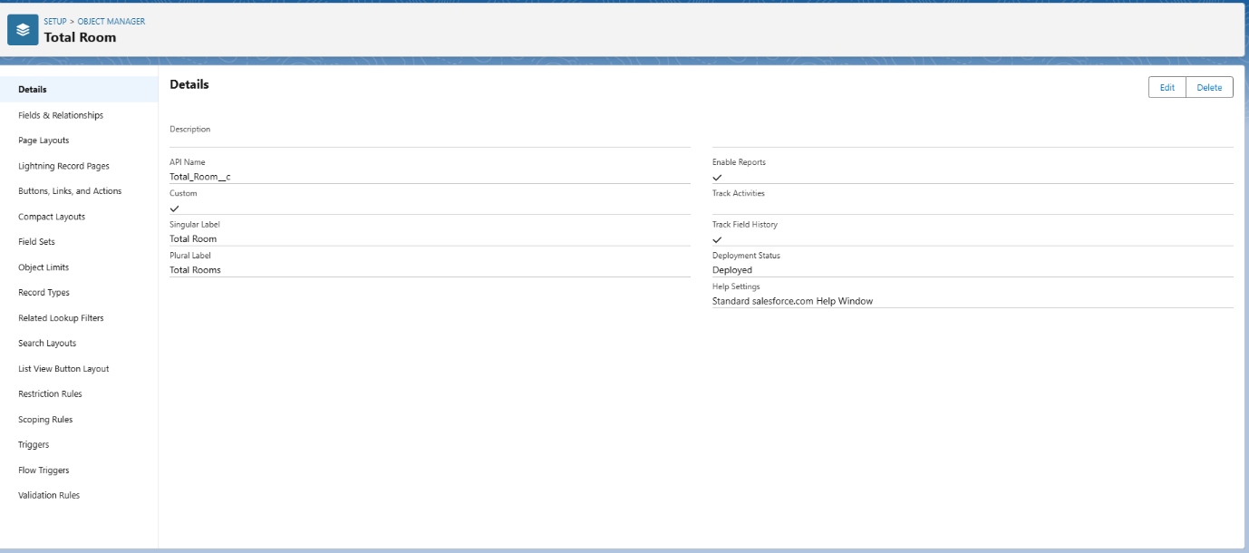

**Create a custom object for Customer :**

1. From setup click on object manager.
2. Click create, select custom object.
3. Fill in the label as " Customer1 ".
4. Fill in the plural label as " Customers ".
5. Record name: "Customer Name"
6. Select the data type as "Text".
7. In the Optional Features section, select Allow Reports and Track Field History.
8. In the Deployment Status section, ensure Deployed is selected.
9. In the Search Status section, select Allow Search.
10. In the Object Creation Options section, select Add Notes and Attachments related list to default page layout.
11. Leave everything else as is, and click Save.

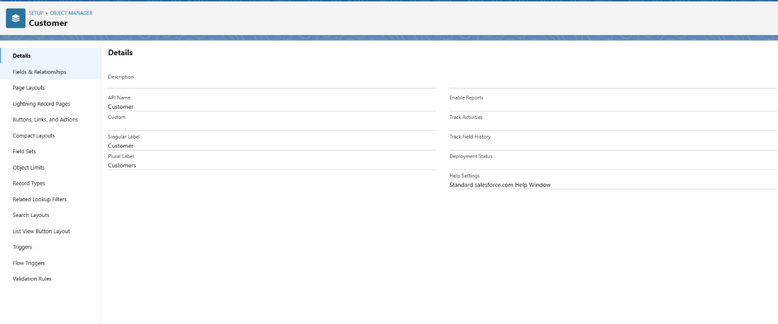

**Create a custom object for Room Booking :**

1. From setup click on object manager.
2. Click create, select custom object.
3. Fill in the label as " Room Booking ".
4. Fill in the plural label as " Room Bookings ".
5. Record name: "Room No "
6. Select the data type as "Auto number ".
7. Under Display format enter RN-{000}
8. Enter starting Number as 1
9. In the Optional Features section, select Allow Reports and Track Field History.
10. In the Deployment Status section, ensure Deployed is selected.
11. In the Search Status section, select Allow Search.
12. In the Object Creation Options section, select Add Notes and Attachments related list to default page layout.
13. Leave everything else as is, and click Save.

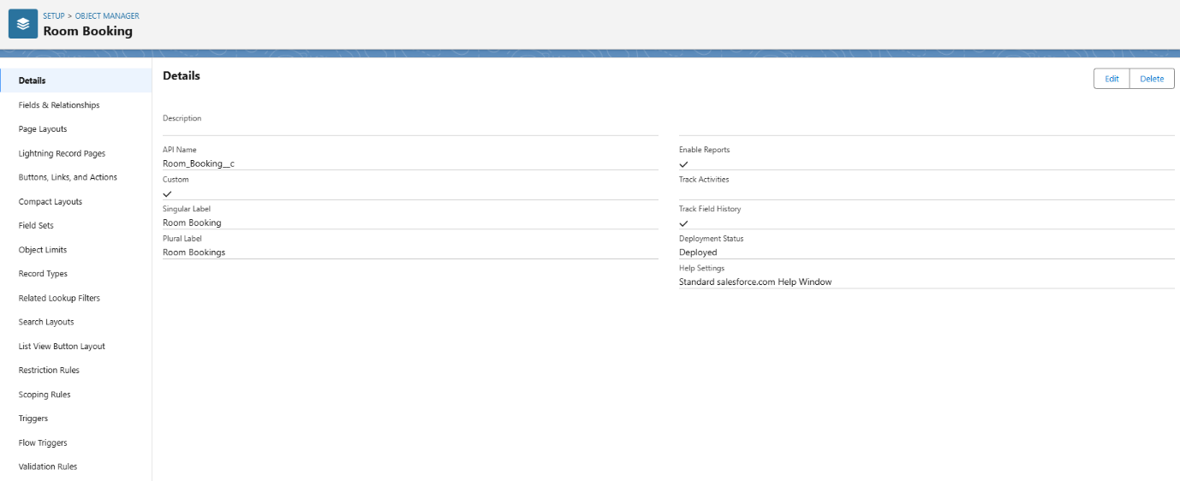

**Create a custom object for Payment :**

1. 1.From setup click on object manager.
2. 2.Click create, select custom object.
3. 3.Fill in the label as " Payment".
4. 4.Fill in the plural label as " Payments ".
5. 5.Record name: "Payment No "
6. 6.Select the data type as "Auto number ".
7. 7.Under Display format enter PNO-{000}
8. 8.Enter starting Number as 1
9. 9.In the Optional Features section, select Allow Reports and Track Field History.
10. 10.In the Deployment Status section, ensure Deployed is selected.
11. 11.In the Search Status section, select Allow Search.
12. 12.In the Object Creation Options section, select Add Notes and Attachments related list to default page layout.
13. 13.Leave everything else as is, and click Save.

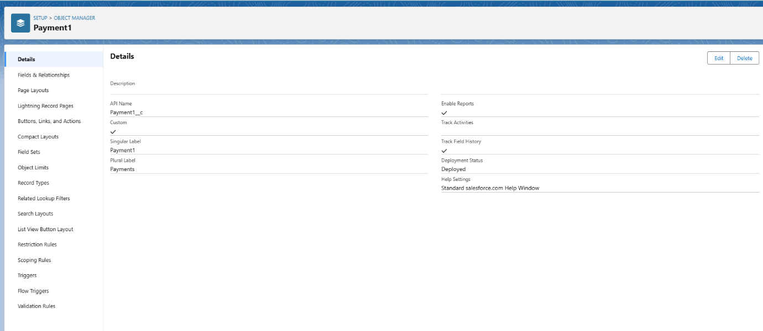

### **Create a custom object for Food Selection**

1. From setup click on object manager.
2. Click create, select custom object.
3. Fill in the label as " Food Selection ".
4. Fill in the plural label as " Food Selections ".
5. Record name: " Food Selection No "
6. Select the data type as "Auto number ".
7. Under Display format enter FS No-{000}
8. Enter starting Number as 1
9. In the Optional Features section, select Allow Reports and Track Field History.
10. In the Deployment Status section, ensure Deployed is selected.
11. In the Search Status section, select Allow Search.
12. In the Object Creation Options section, select Add Notes and Attachments related list to default page layout.
13. Leave everything else as is, and click Save.

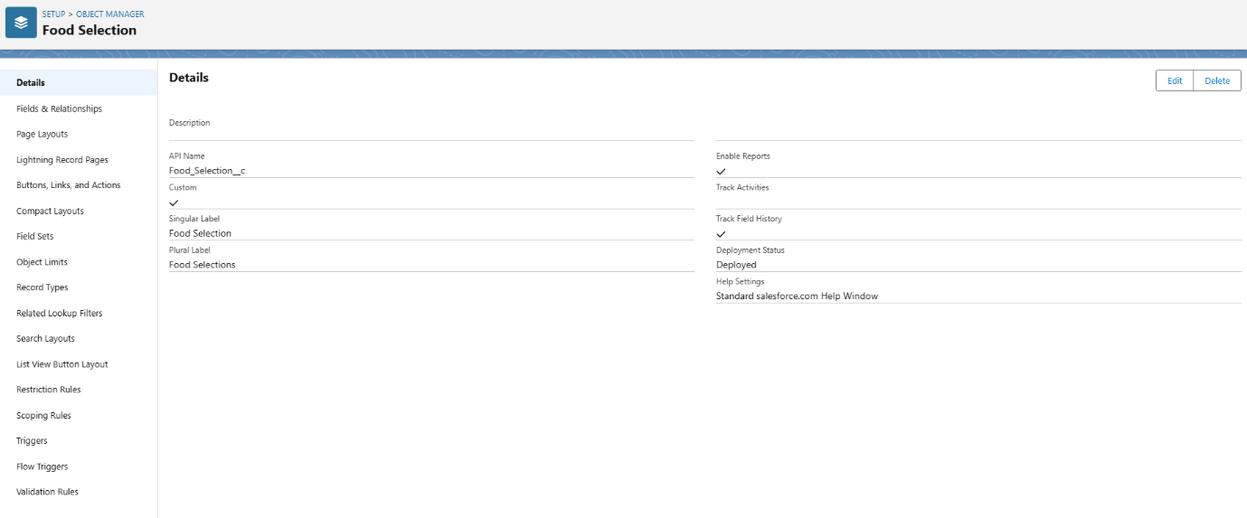

### **Create a custom object for Feedback**

1. From setup click on object manager.
2. Click create, select custom object.
3. Fill in the label as " Feedback ".
4. Fill in the plural label as " Feedbacks ".
5. Record name: "Feedback No "
6. Select the data type as "Auto number ".
7. Under Display format enter Fd No-{0000}
8. Enter starting Number as 1
9. In the Optional Features section, select Allow Reports and Track Field History.
10. In the Deployment Status section, ensure Deployed is selected.
11. In the Search Status section, select Allow Search.
12. In the Object Creation Options section, select Add Notes and Attachments related list to default page layout.
13. Leave everything else as is, and click Save.

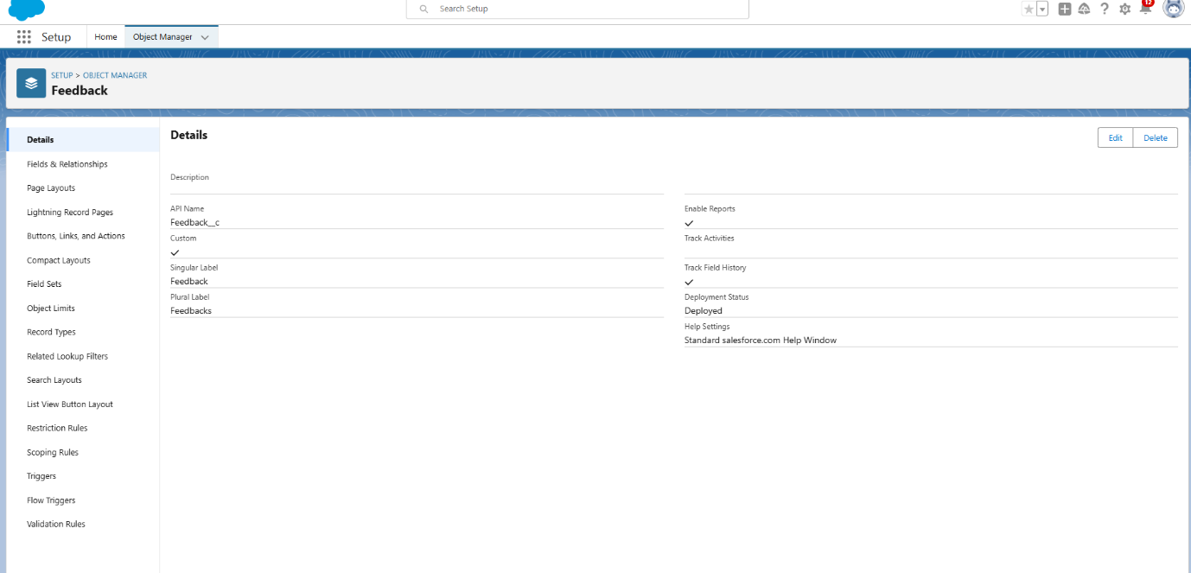

**TASK 3:** Tab Creation

### **Creating a Tab for Total Rooms**

**To create a Tab:(Total Rooms)**1. Go to setup page > type Tabs in Quick Find bar > click on tabs > New (under custom object tab)

2. Select Object(Total Rooms) > Select the tab style.

3. Next (Add to profiles page) keep it as default

4. Next (Add to Custom App) keep it as default & Save.

5.From above process create all required custom Tabs.

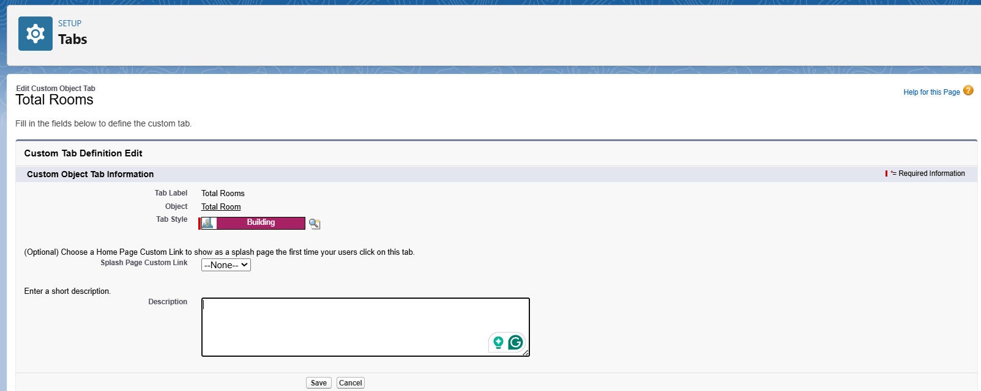

### **Create a Tab for Customers**

1. Go to setup page > type Tabs in Quick Find bar > click on tabs > New (under custom object tab)
2. Select Object(Customers) > Select the tab style > Next (Add to profiles page) keep it as default > Next (Add to Custom App) keep it as default > Save.

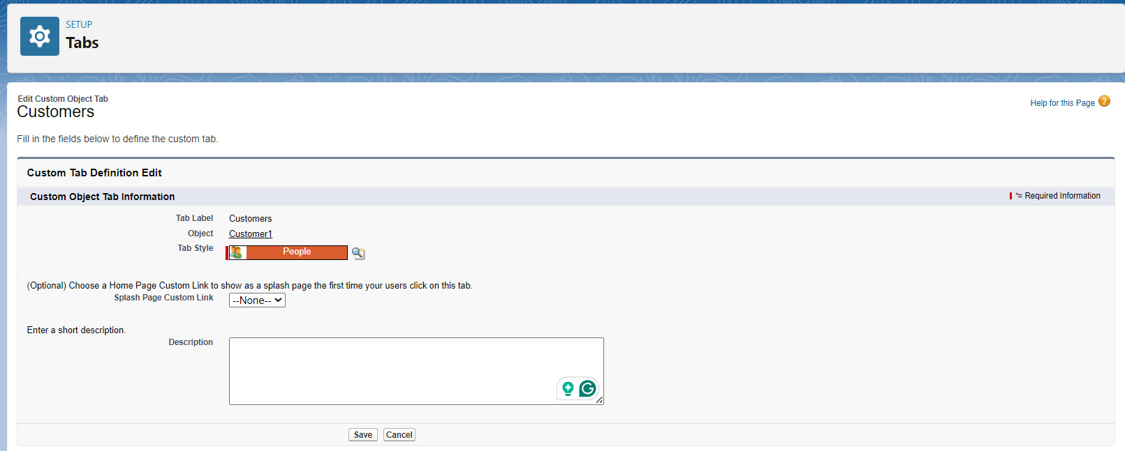

### **To create a Tab for Room Bookings**

1. Go to setup page ? type Tabs in Quick Find bar ? click on tabs ? New (under custom object tab)
2. Select Object(Room Bookings) ? Select the tab style ? Next (Add to profiles page) keep it as default ? Next (Add to Custom App) keep it as default ? Save.

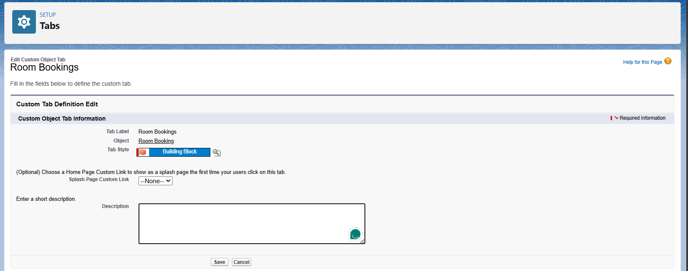

### **Create a Tab for payments**

1. Go to setup page > type Tabs in Quick Find bar > click on tabs > New (under custom object tab)
2. Select Object(Payments) > Select the tab style > Next (Add to profiles page) keep it as default > Next (Add to Custom App) keep it as default > Save.

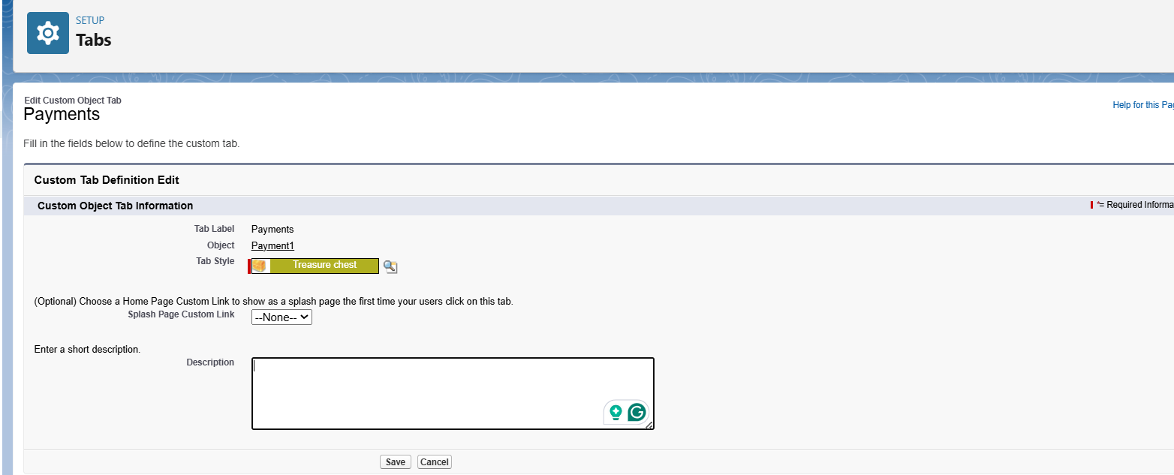

### **Create a Tab for Food selection**

1. Go to setup page > type Tabs in Quick Find bar > click on tabs > New (under custom object tab)
2. Select Object(Food selection) > Select the tab style > Next (Add to profiles page) keep it as default > Next (Add to Custom App) keep it as default > Save.

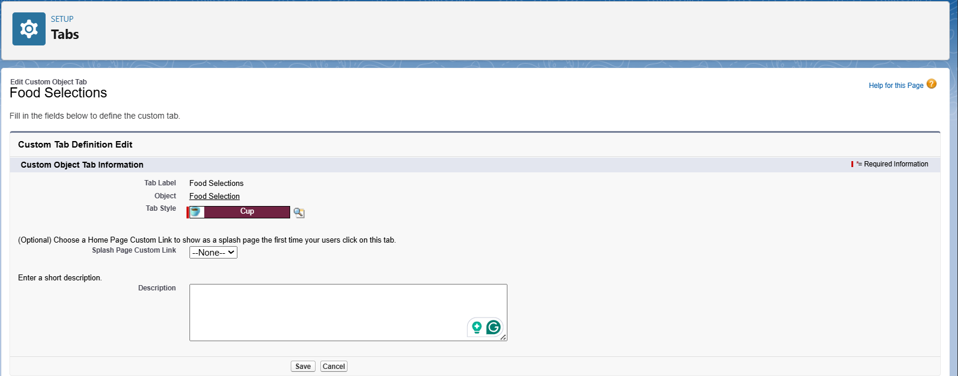

### **Create a Tab for Feedbacks**

1. Go to setup page > type Tabs in Quick Find bar > click on tabs > New (under custom object tab)
2. Select Object(Feedbacks) > Select the tab style > Next (Add to profiles page) keep it as default > Next (Add to Custom App) keep it as default > Save.

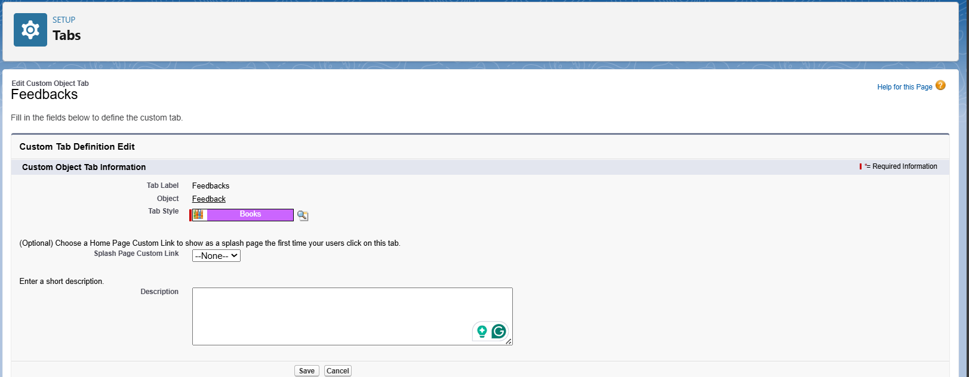

**TASK 4:**Lightning App Creation

### **Create a Lightning App**

1. Go to setup page > search “app manager” in quick find > select “app manager” > click on New lightning App.

2. Fill the app name in app details and branding > Next  > (App option page) keep it as default > Next > (Utility Items) keep it as default > Next.

3. To Add Navigation Items: Ctrl and Select the items (Total Rooms, Customers1, Room Booking, Payments1, Food selection, Feedbacks, Reports and Dashboards) from the search bar and move it using the arrow button > Next.

4. To Add User Profiles:

5. Search profiles (System administrator) in the search bar > click on the arrow button > save & finish.

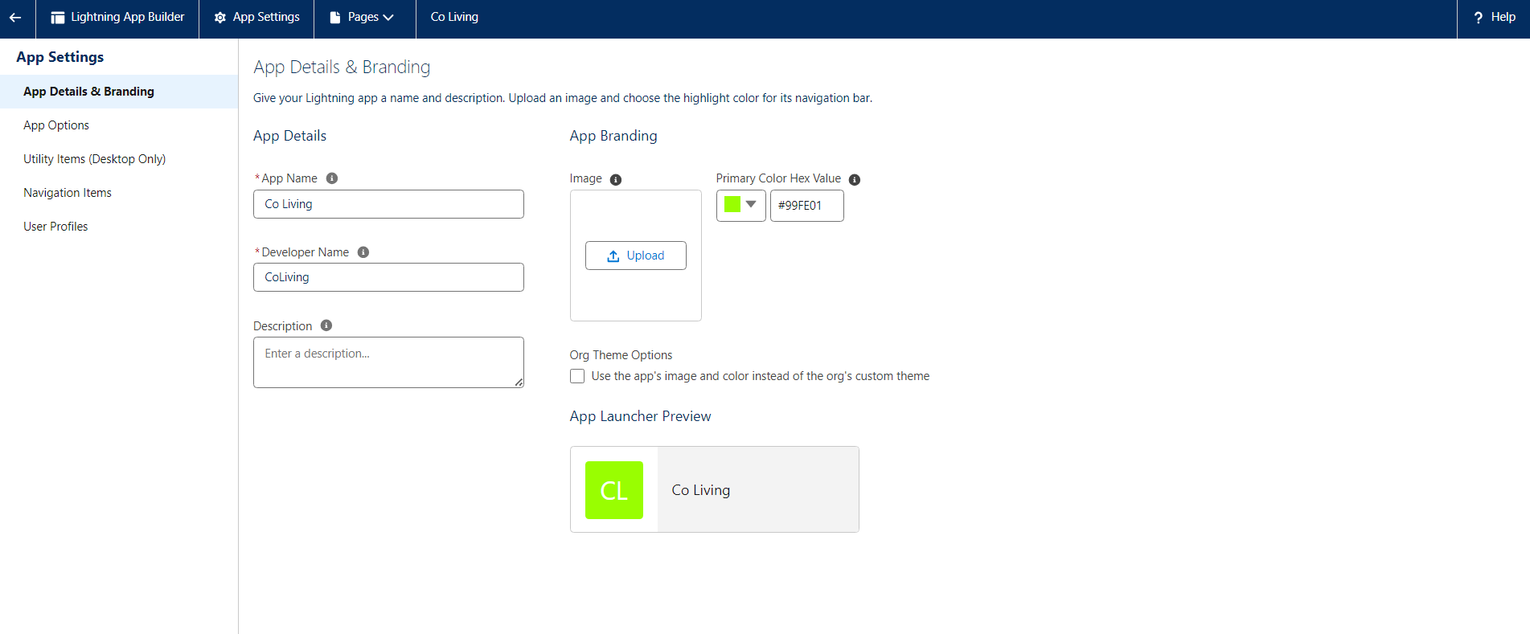

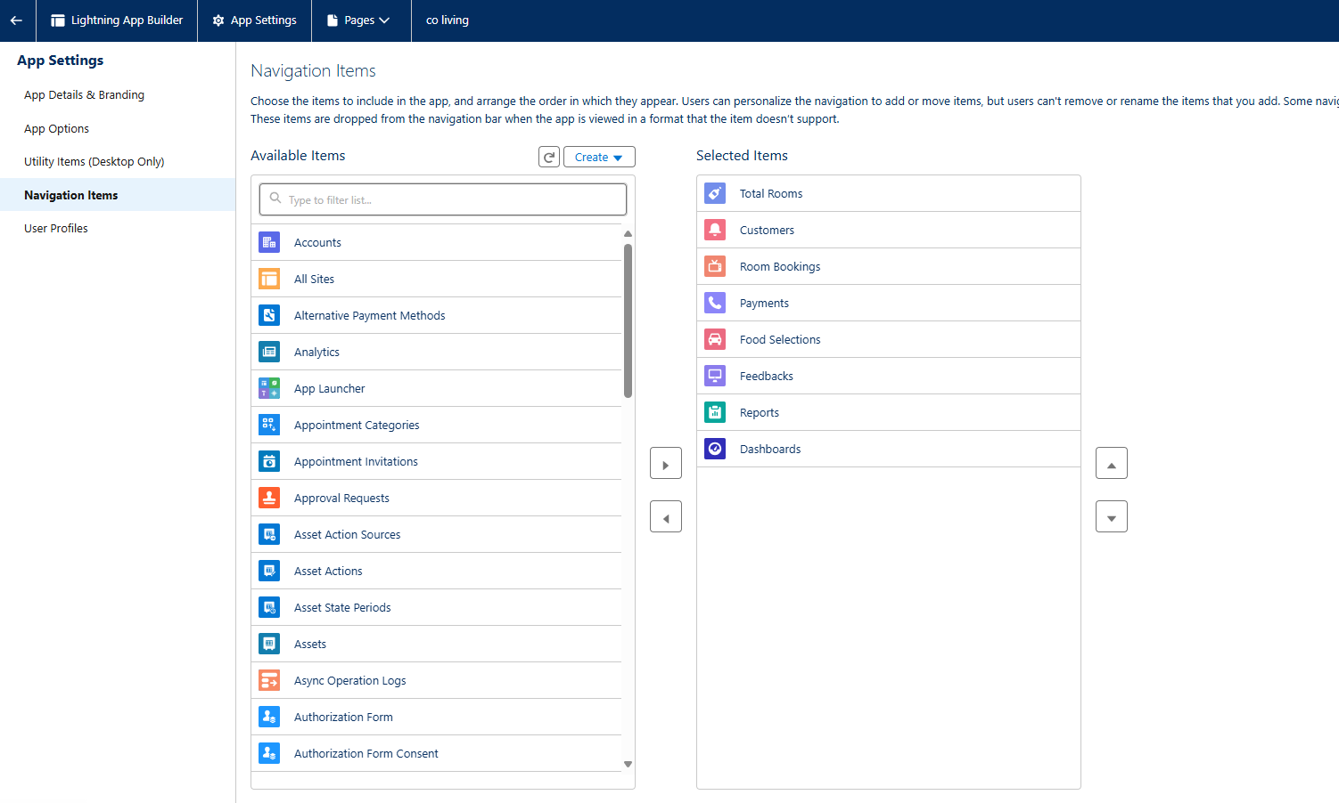

**Task 5:Fields and Relationships**

### **Creation of fields for the customer1 object**

**1. To create fields in an object:**1. Go to setup > click on Object Manager > type object name(Customer1) in search bar > click on the object.  
2. Now click on “Fields & Relationships” > New  
3. Select Data Type as a “Phone”  
4. Click on next  
5. Fill the Above as following:

1. Field Label: Phone no
2. Field Name : gets auto generated
3. Click on Next > Next > Save and new.

**2. To create another fields in an object:**

1. Go to setup > click on Object Manager > type object name(Customer1) in search bar > click on the object.
2. Now click on “Fields & Relationships” > New
3. Select Data type as a “Email” and Click on Next
4. Fill the Above as following:

* Field Label: Email
* Field Name :It’s  gets auto generated
* Click on Next > Next > Save and new.

**3. To create another fields in an object:**

1. Go to setup > click on Object Manager > type object name(Customer1) in search bar > click on the object.
2. Now click on “Fields & Relationships” ? New
3. Select Data type as a “Text Area” and Click on Next
4. Fill the Above as following:

* Field Label: Permanent Address
* Field Name : It’s gets auto generated
* Click on Next > Next > Save and new.

**4. To create another fields in an object:**

1. Go to setup > click on Object Manager > type object name(Customer1) in search bar > click on the object.
2. Now click on “Fields & Relationships” > New
3. Select Data type as a “Picklist” and Click on Next
4. Fill the Above as following:

* Field Label: Current Status
* Value - Select enter values with each value separated by a new line

1. Student
2. Employee
3. Others

* Select required
* Field Name :It’s gets auto generated
* Click on Next > Next > Save and new.

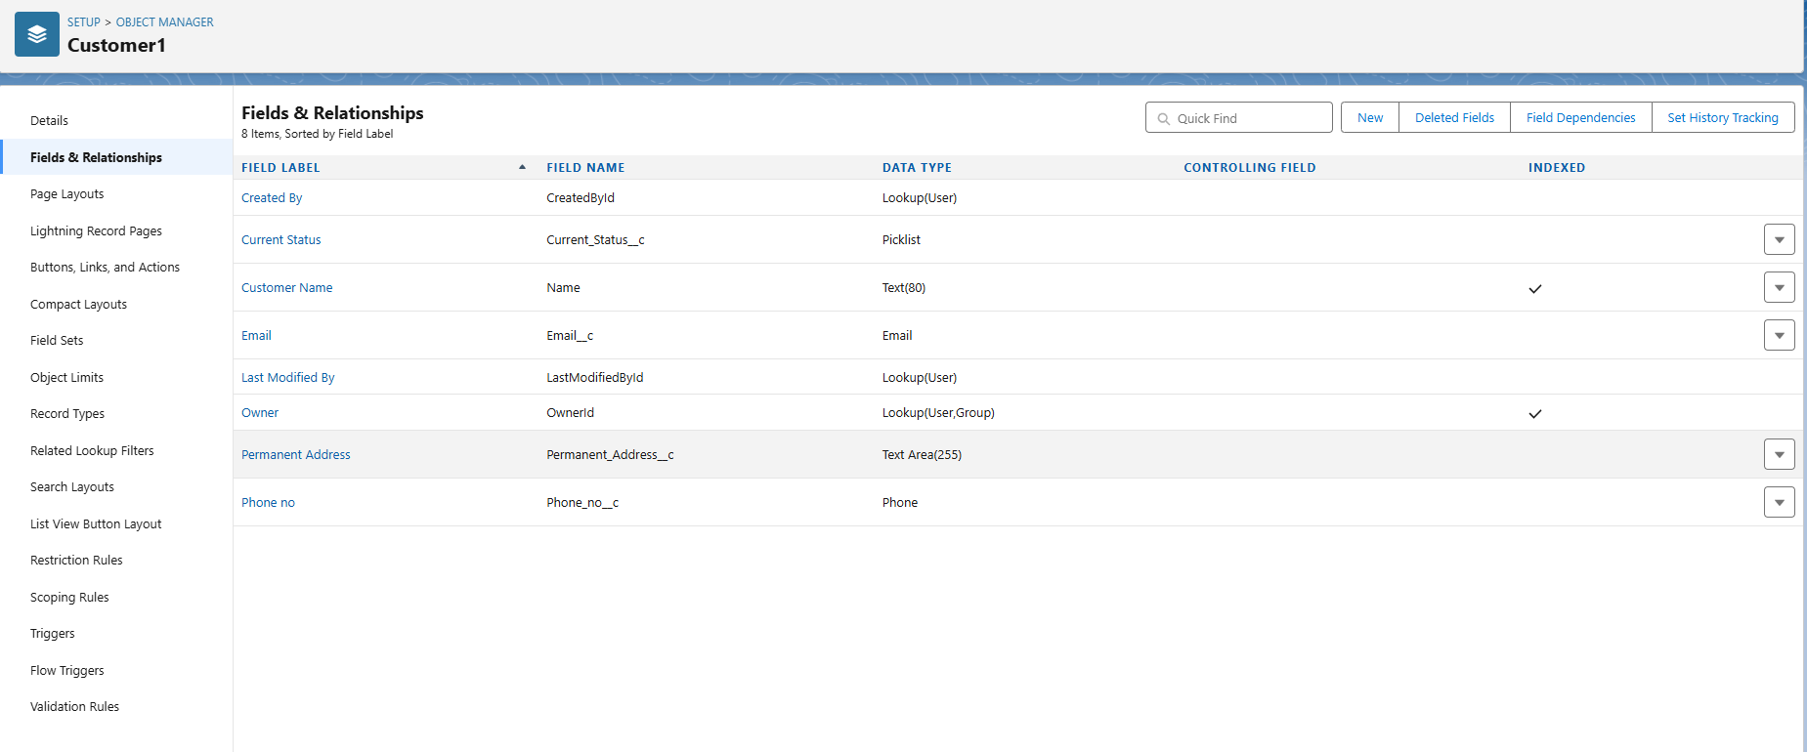

### **Creation of fields for the Room Booking object**

**1. To create fields in an object:**

1. Go to setup > click on Object Manager > type object name(Room Booking) in the search bar > click on the object.

1. Now click on “Fields & Relationships” > New
2. Select Data Type as a “Picklist”
3. Click on Next
4. Fill the Above as following:

* Field Label: Room Sharing
* Value - Select enter values with each value separated by a new line

1. Single sharing
2. Double sharing
3. Triple sharing

* Select required
* Click on Next > Next > Save and new.

**2. To Create a Fields & Relationship to an Room Booking Object**

To create fields & relationship to an object:

1. Go to setup > click on Object Manager > type object name(Room Booking) in the search bar > click on the object.
2. Now click on “Fields & Relationships” > New
3. Select Data Type as a “Master-detail Relationship”
4. Click on Next
5. Click on the Related to drop down and Select the “Customer1” object and click on Next
6. Fill the Above as following:

* Change the Field Label: Name
* Field Name : It’s gets auto generated
* Click on Next > Next > Save and new.

**3. To create fields in an object:**

1. Go to setup > click on Object Manager > type object name(Room Booking) in the search bar > click on the object.
2. Now click on “Fields & Relationships” > New
3. Select Data Type as a “Checkbox”
4. Click on Next
5. Fill the Above as following:

* Field Label: AC-3000
* Field Name :It’s gets auto generated
* Click on Next > Next > Save and new

**4. To create fields in an object:**

1. Go to setup > click on Object Manager > type object name(Room Booking) in the search bar > click on the object.
2. Now click on “Fields & Relationships” > New
3. Select Data Type as a “Checkbox”
4. Click on Next
5. Fill the Above as following:

* Field Label: Advance Payment for 1 Month
* Field Name :It’s gets auto generated
* Click on Next > Next > Save and new

**5. To create fields in an object:**

1. Go to setup ? click on Object Manager ? type object name(Room Booking) in the search bar ? click on the object.
2. Now click on “Fields & Relationships” ? New
3. Select Data Type as a “Currency”
4. Click on Next
5. Fill the Above as following:

* Field Label: Amount
* Length: (18,0)
* Field Name :It’s gets auto generated
* Click on Next > Next > Save and new

**6. To Create a Fields & Relationship to an Object**

1. Go to setup > click on Object Manager > type object name(Room Booking) in the search bar > click on the object.
2. Now click on “Fields & Relationships” ? New
3. Select Data Type as a “Master-detail Relationship”
4. Click on Next
5. Click on the Related to drop down and Select the “Total Rooms” object and click on Next

* Fill the Above as following:
* Change the Field Label: Total No Of Rooms
* Field Name :It’s gets auto generated
* Click on Next > Next > Save and new.

**7. To Create a Rollup Summary Field in “Total Room Object”**

1. After Creating the Master- Detail Relationship Than Only you can create the Rollup Summary
2. Go to setup > click on Object Manager > type object name(Total Rooms) in the search bar > click on the object.
3. Now click on “Fields & Relationships” ? New
4. Select Data type as a “Roll-up Summary” and Click on Next

* Fill the Above as following:
* Field Label: Rooms Booked
* Field Name :It’s gets auto generated
* Click on Next

1. Select the Room Bookings in the Summarized Object
2. Select the count Radio button in the select Roll-up Type
3. Click on Next > Next > Save and new

**8. To create fields in an object:**

1. Go to setup > click on Object Manager > type object name(Rooms Booking) in the search bar > click on the object.
2. Now click on “Fields & Relationships” > New
3. Select Data type as a “Formula” and Click on Next
4. Fill the Above as following:

* Field Label: Rooms Available
* Field Name : It’s gets auto generated
* Select the Formula Return Type as “Number”
* Select the Decimal places as “0” and Click on Next
* Click on the Advanced Formula and Enter the value in formula box “ 30 - ” and Click on insert field than you will find a pop window under the Room Booking select the Total No Of Rooms in the second Column and select the Room Booked in the third column and click on insert “ 30  -  Total_No_Of_Rooms__r.Rooms_Booked__c ” and Check Syntax
* Click on Next > Next > Save and new.

**9. To create fields in an object:**

1. Go to setup > click on Object Manager > type object name(Room Booking) in the search bar > click on the object.
2. Now click on “Fields & Relationships” > New
3. Select Data Type as a “Checkbox”
4. Click on Next
5. Fill the Above as following:

* Field Label: Check in
* Field Name :It’s gets auto generated
* Click on Next > Next > Save and new

**10. To create fields in an object:**

1. Go to setup > click on Object Manager > type object name(Room Booking) in the search bar > click on the object.
2. Now click on “Fields & Relationships” ? New
3. Select Data Type as a “Checkbox”
4. Click on Next
5. Fill the Above as following:

* Field Label: Check Out
* Field Name :It’s gets auto generated
* Click on Next > Next > Save and new

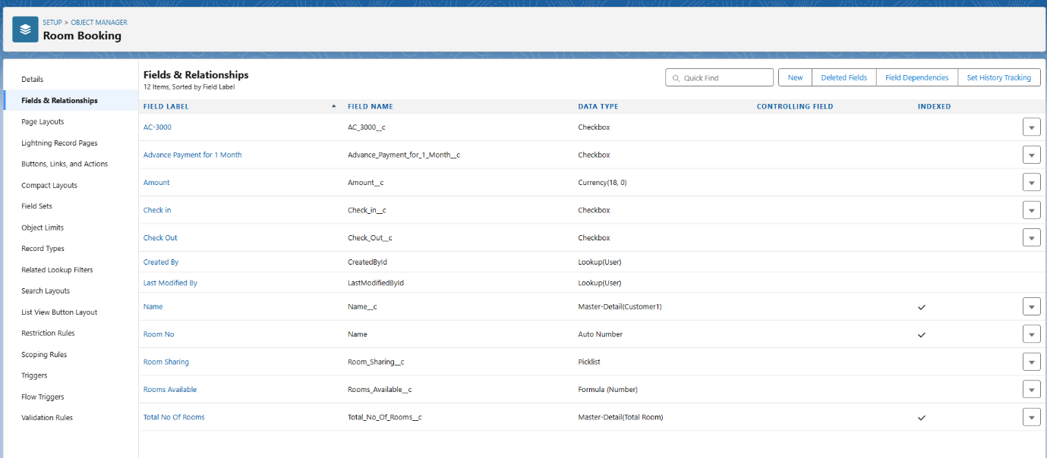

### **Creation of Fields & Relationship for Payment1 Object**

**1. To create fields & relationship to an object:**

1. Go to setup > click on Object Manager > type object name(Payment1) in the search bar > click on the object.
2. Now click on “Fields & Relationships” > New
3. Select Data Type as a “Master-detail Relationship”
4. Click on Next
5. Click on the Related to drop down and Select the Customer1 object and click on Next
6. Fill the Above as following:

* Change the Field Label: Name
* Field Name :It’s gets auto generated
* Click on Next > Next > Save and new.

**2. To create another fields & relationship to an object:**

1. Go to setup > click on Object Manager > type object name(Payment1) in the search bar > click on the object.
2. Now click on “Fields & Relationships” > New
3. Select Data Type as a “Lookup Relationship”
4. Click on Next
5. Click on the Related to drop down and Select the Room Booking object and click on Next
6. Fill the Above as following:

* Change the Field Label: Room Booking
* Field Name :It’s gets auto generated
* Click on Next > Next > Save and new.

**3. Creation of another fields for the Payment1 object**

To create fields in an object:

1.Go to setup > click on Object Manager > type object name(Payment1) in the

search bar > click on the object.

2. Now click on “Fields & Relationships” > New

3.Select Data Type as a “Picklist”

4.Fill the Above as following:

* Field Label: Payment Mode
* Value - Select enter values with each value separated by a new line

1. Cash
2. Check
3. Credit card
4. Debit card
5. UPI
6. Phonepe
7. Gpay
8. Paytm

* Select required
* Click on Next > Next > Save and new.

**4. Create a Cross object formula Field in Payment1 Object**

1. Go to setup > click on Object Manager > type object name(Payment1) in the search bar > click on the object.
2. Now click on “Fields & Relationships” > New
3. Select Data Type as a “Formula”
4. Click on Next
5. Enter the Field label: Amount and Field name: gets auto generated and click on Next
6. In the Advanced Formula Click on the Insert field in the popup Screen Select the Payment1 and in the second drop down select the Room Booking and in the three drop down select the Amount field and click on Insert “ Room_Booking__r.Amount__c ”.
7. Click on the Check syntax: No syntax errors in merge fields
8. Click on Next > Next > Save and new.

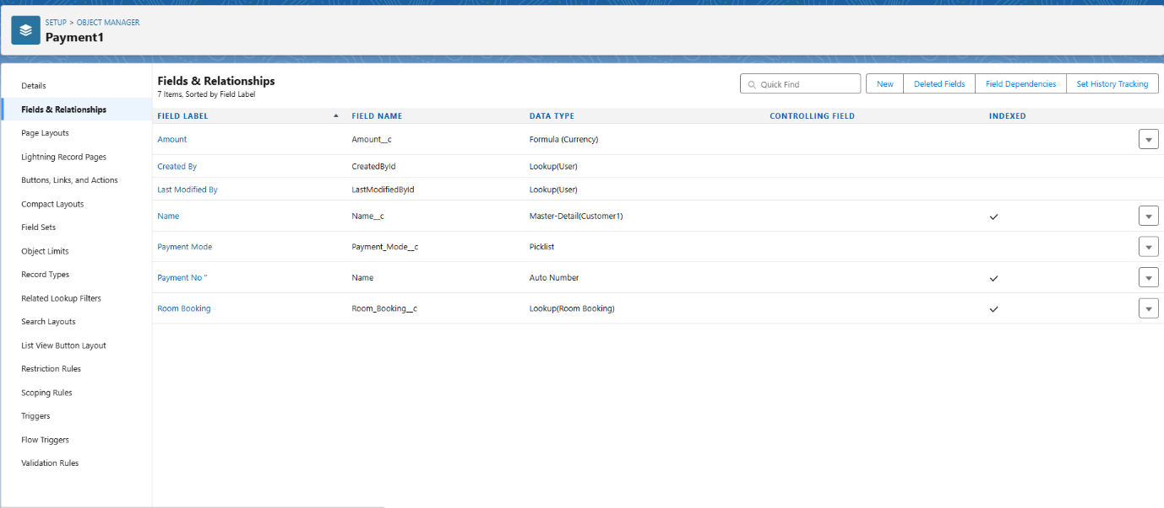

### **Creation of Fields & Relationship for Food Selection Object**

**1. To create fields & relationship to an object:**

1. Go to setup > click on Object Manager > type object name(Room Booking) in the search bar > click on the object.
2. Now click on “Fields & Relationships” > New
3. Select Data Type as a “Master-detail Relationship”
4. Click on Next
5. Click on the Related to drop down and Select the Customer1 object and click on Next
6. Fill the Above as following:

* Change the Field Label: Name
* Field Name :It’s gets auto generated
* Click on Next > Next > Save and new.

**Create a picklist value set:**

1. First click on gear icon and click on setup
2. Click on home tab in the Quick find box search for the “ Picklist value sets ”
3. Click on the Picklist value set and click on new
4. Enter the Label name and API name automatically Generate
5. Enter the values with each value separated by a new line

* Sunday
* Monday
* Tuesday
* Wednesday
* Thursday
* Friday
* Saturday

1. Check the Use first value as default value and Click on save.

**2. Create a picklist Field for Food selection object**

To create fields in an object:

1. Go to setup > click on Object Manager > type object name(Food Selection) in the search bar > click on the object.
2. Now click on “Fields & Relationships” > New
3. Select Data Type as a “Picklist”
4. Fill the Above as following:

* Field Label: Breakfast
* Under Value - Select the Use global picklist value set
* Under the drop down select the Custom Picklist Values
* Select required
* Click on Next > Next > Save and new.

**3. Create a another picklist Field for Food selection object**

To create fields in an object :

1. Go to setup > click on Object Manager > type object name(Food Selection) in the search bar > click on the object.
2. Now click on “Fields & Relationships” > New
   1. Select Data Type as a “Picklist”
   2. Fill the Above as following:
   * Field Label: Select Breakfast
   * Under Value - Enter values, with each value separated by a new line
   * Idli
   * Bonda
   * Dosa
   * Upma
   * Vada
   * Puri
   * Chapati
   * Select Checkbox Use First value as default Value
   * Click on Next > Next > Save and new.

**Create a Field Dependency on Breakfast and Select Breakfast Fields in Food Selection Object.**

1. Go to setup > click on Object Manager > type object name(Food Selection) in the search bar > click on the object.
2. Now Click on fields & relationships and Click on Field Dependencies
3. Now Click on New Option
4. Under Controlling Field: Breakfast, Dependent Field: Select Breakfast and Click on Continue
5. Under the Sunday Ctrl and select the Picklist values Idli,Dosa,Puri and Click on Include Values in such a way that do for the remaining days and click on save.

**4. To create fields in an object:**

1. Go to setup > click on Object Manager > type object name(Food Selection) in the search bar ? click on the object.
2. Now click on “Fields & Relationships” > New
3. Select Data Type as a “Picklist”
4. Fill the Above as following:

* Field Label: Lunch
* Under Value - Select the Use global picklist value set
* Under the drop down select the Custom Picklist Values
* Select required
* Click on Next > Next > Save and new.

**5. To create fields in an object:**

1. Go to setup > click on Object Manager > type object name(Food Selection) in the search bar > click on the object.
2. Now click on “Fields & Relationships” > New
3. Select Data Type as a “Picklist”
4. Fill the Above as following:

* Field Label: Select Lunch
* Under Value - Enter values, with each value separated by a new line

1. Meals
2. Chicken biryani
3. Veg biryani
4. Veg fried rice
5. Egg fried rice
6. Chicken fried rice
7. Curd rice
8. Tomato rice
9. Egg noodles
10. Chicken Noodles
11. Bhagara rice

* Select Checkbox Use First value as default Value
* Click on Next > Next > Save and new.

**To create a Field dependencies for Lunch and Select Lunch.**

1. Go to setup > click on Object Manager > type object name(Food Selection) in the search bar > click on the object.
2. Now Click on fields & relationships and Click on Field Dependencies
3. Now Click on New Option
4. Under Controlling Field:Lunch, Dependent Field: Select Lunch and Click on Continue
5. Under the Sunday Ctrl and select the Picklist values Chicken biryani, Egg fried rice, curd rice and Click on Include Values in such a way that do for the remaining days and click on save.

**6. To create fields in an object:**

1. Go to setup > click on Object Manager > type object name(Food Selection) in the search bar > click on the object.
2. Now click on “Fields & Relationships” > New
3. Select Data Type as a “Picklist”
4. Fill the Above as following:

* Field Label: Dinner
* Under Value - Select the Use global picklist value set
* Under the drop down select the Custom Picklist Values
* Select required
* Click on Next > Next > Save and new.

**7. To create fields in an object:**

1. Go to setup > click on Object Manager > type object name(Food Selection) in the search bar > click on the object.
2. Now click on “Fields & Relationships” > New
3. Select Data Type as a “Picklist”
4. Fill the Above as following:

* Field Label: Select Dinner
* Under Value - Enter values, with each value separated by a new line
  1. Meals
  2. Chicken biryani
  3. Veg biryani
  4. Veg fried rice
  5. Egg fried rice
  6. Chicken fried rice
  7. Curd rice
  8. Tomato rice
  9. Egg noodles
  10. Chicken Noodles
  11. Bhagara rice
  + Select Checkbox Use First value as default Value
  + Click on Next > Next > Save and new.

**To create a Field dependencies for Dinner and Select Dinner.**

* + Go to setup > click on Object Manager > type object name(Food Selection) in the search bar > click on the object.
  + Now Click on fields & relationships and Click on Field Dependencies
  + Now Click on New Option
  + Under Controlling Field: Dinner, Dependent Field: Select Dinner and Click on Continue
  + Under the Sunday Ctrl and select the Picklist values Chicken biryani, curd rice, Chicken noodles and Click on Include Values in such a way that do for the remaining days and click on save.

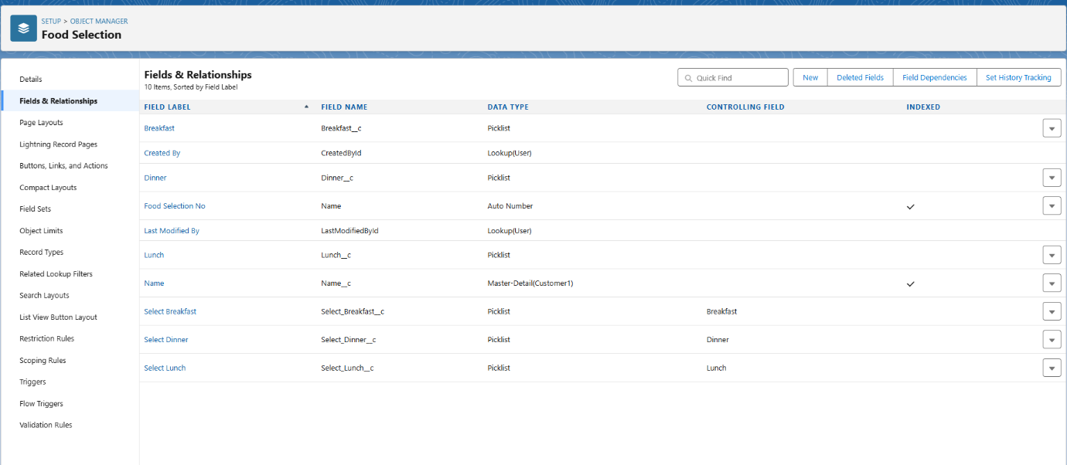

### **Creation of fields for the Feedback object**

**1. create fields & relationship to an object:**

1. Go to setup > click on Object Manager > type object name(Feedback) in search bar > click on the object.
2. Now click on “Fields & Relationships” > New
3. Select Data Type as a “Lookup Relationship”
4. Click on Next
5. Click on the Related to drop down and Select the Customer1 object and click on Next
6. Fill the Above as following:

* Change the Field Label: Name
* Field Name :It’s gets auto generated
* Click on Next > Next > Save and new.

**2. To create Another fields in an Same object:**

1. Go to setup > click on Object Manager > type object name(Feedback) in search bar > click on the object.
2. Now click on “Fields & Relationships” > New
3. Select Data Type as a “Picklist”
4. Click on Next
5. Fill the Above as following:

* Field Label: Roomcleaning
* Field Name :It’s gets auto generated
* Under Values select Enter values, with each value separated by a new line

1. Good
2. Satisfaction
3. Bad

* Click on Next > Next > Save and new.

**3. To create a Another Fields in an Same Object**

1. Go to setup > click on Object Manager > type object name(Feedback) in search bar > click on the object.
2. Now click on “Fields & Relationships” ? New
3. Select Data Type as a “Picklist”
4. Click on Next
5. Fill the Above as following:

* Field Label: Internet
* Field Name :It’s gets auto generated
* Under Values select Enter values, with each value separated by a new line

1. Good
2. Satisfaction
3. Bad

* Click on Next > Next > Save and new.

**4. To create a Another Fields in an Same Object**

1. Go to setup > click on Object Manager > type object name(Feedback) in search bar > click on the object.
2. Now click on “Fields & Relationships” ? New
3. Select Data Type as a “Picklist”
4. Click on Next
5. Fill the Above as following:

* Field Label: Food
* Field Name :It’s gets auto generated
* Under Values select Enter values, with each value separated by a new line

1. Good
2. Satisfaction
3. Bad

* Click on Next > Next > Save and new.

**5. To create a Another Fields in an Same Object**

1. Go to setup > click on Object Manager > type object name(Feedback) in search bar > click on the object.
2. Now click on “Fields & Relationships” > New
3. Select Data Type as a “Text area”
4. Click on Next
5. Fill the Above as following:

* Field Label: Suggestion
* Field Name :It’s gets auto generated
* Click on Next > Next > Save and new.

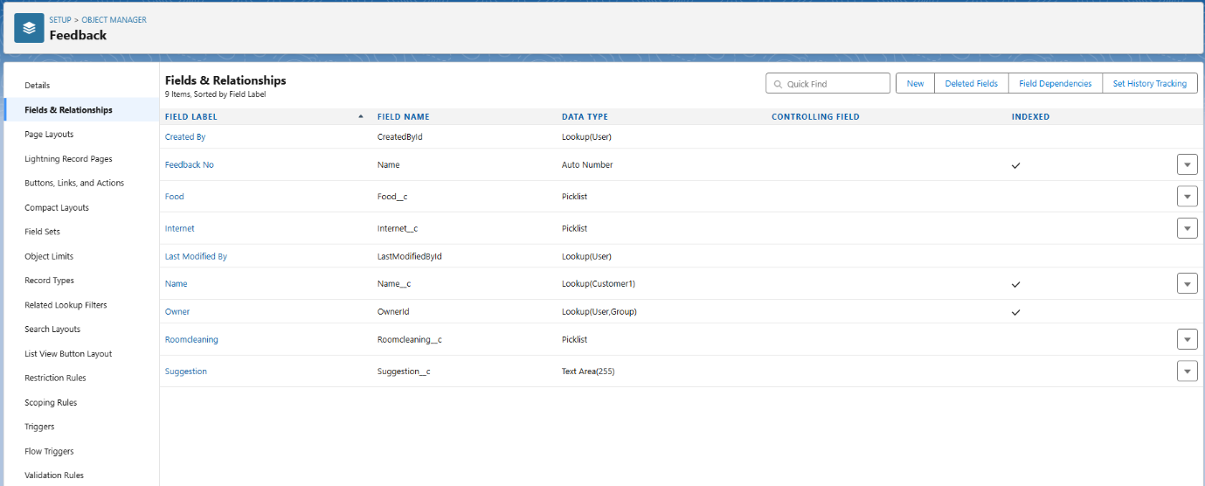

### **Creation of fields for the Total Rooms object**

**1. To create fields in an object:**

1. Go to setup > click on Object Manager > type object name(Total Rooms) in search bar > click on the object.
2. Now click on “Fields & Relationships” > New
3. Select Data type as a “Formula” and Click on Next
4. Fill the Above as following:
5. Field Label: Rooms Available
6. Field Name : It’s gets auto generated
7. Select the Formula Return Type as “Number”
8. Select the Decimal places as “0” and Click on Next

Note: I am Considering “Total No Of Rooms = 30” While creating a new record in Total Rooms Object.

1. Click on the Advanced Formula “ 30 -  Rooms_Booked__c ” and Check Syntax
2. Click on Next > Next > Save and new.

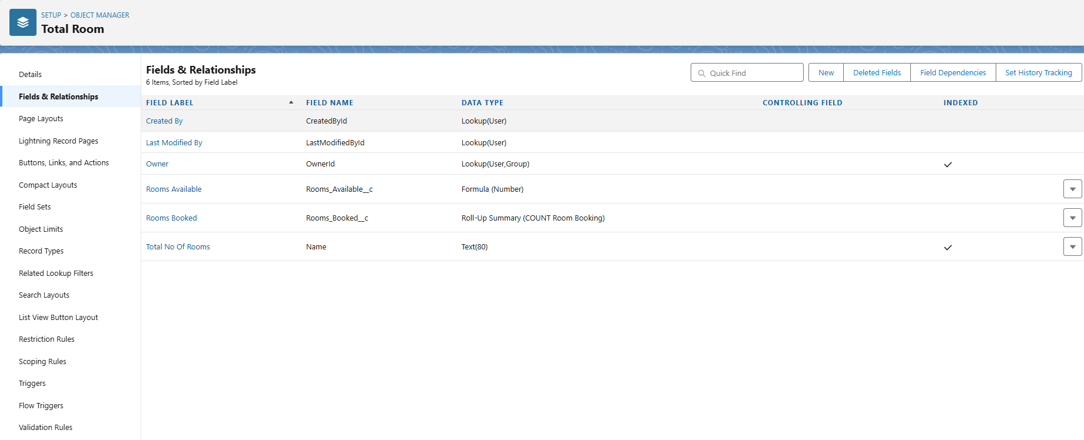

**Task 6:Validation Rule**

**create a validation rule to an Room Booking Object**

Go to setup > click on Object Manager > type object name(Room Booking) in the search bar > click on the object.

Now click on “Validation rule” at top > New.

Enter Rule name “checkbox field” and make the validation should be Active.

Enter the formula in the formula Box “Advance_payment_for_1month__c  =

false” and check for syntax error.

Enter the error message “Checkbox should be checked”

Select error location as field(Advance payment for 1month)

Click on save.

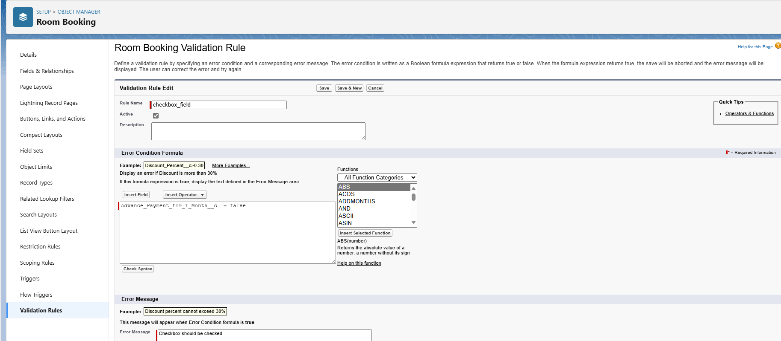

### create a Another validation rule to an Room Booking Object

1. Go to setup > click on Object Manager > type object name(Room Booking) in the search bar > click on the object.
2. Now click on “Validation rule” at top > New.
3. Enter Rule name “check in rule” and make the validation should be Active.
4. Enter the formula in the formula Box “ Check_in__c = False ” and check for syntax error.
5. Enter the error message “Check box should be checked”
6. Select error location as field(Check in)
7. Click on save.

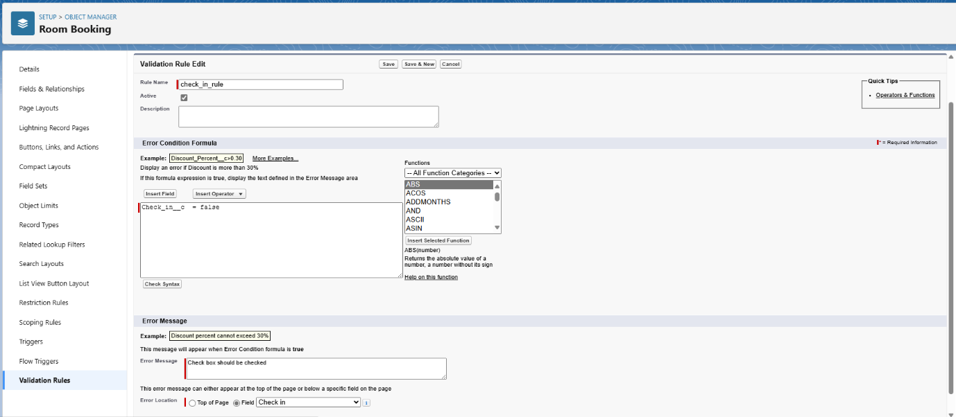

**Task 7:Create profiles**

### **Custom user Profile**

1. Go to setup > type profiles in quick find box > click on profiles > clone the desired profile (Standard User)
2. Enter profile name (Custom User) > Save.
3. While still on the profile page, then click Edit.
4. Scroll down to Custom Object Permissions and Give All access permissions for Customers, Feedbacks, Food selections, Payments, Room Bookings and Total Rooms.
5. Scroll down and Click on Save.

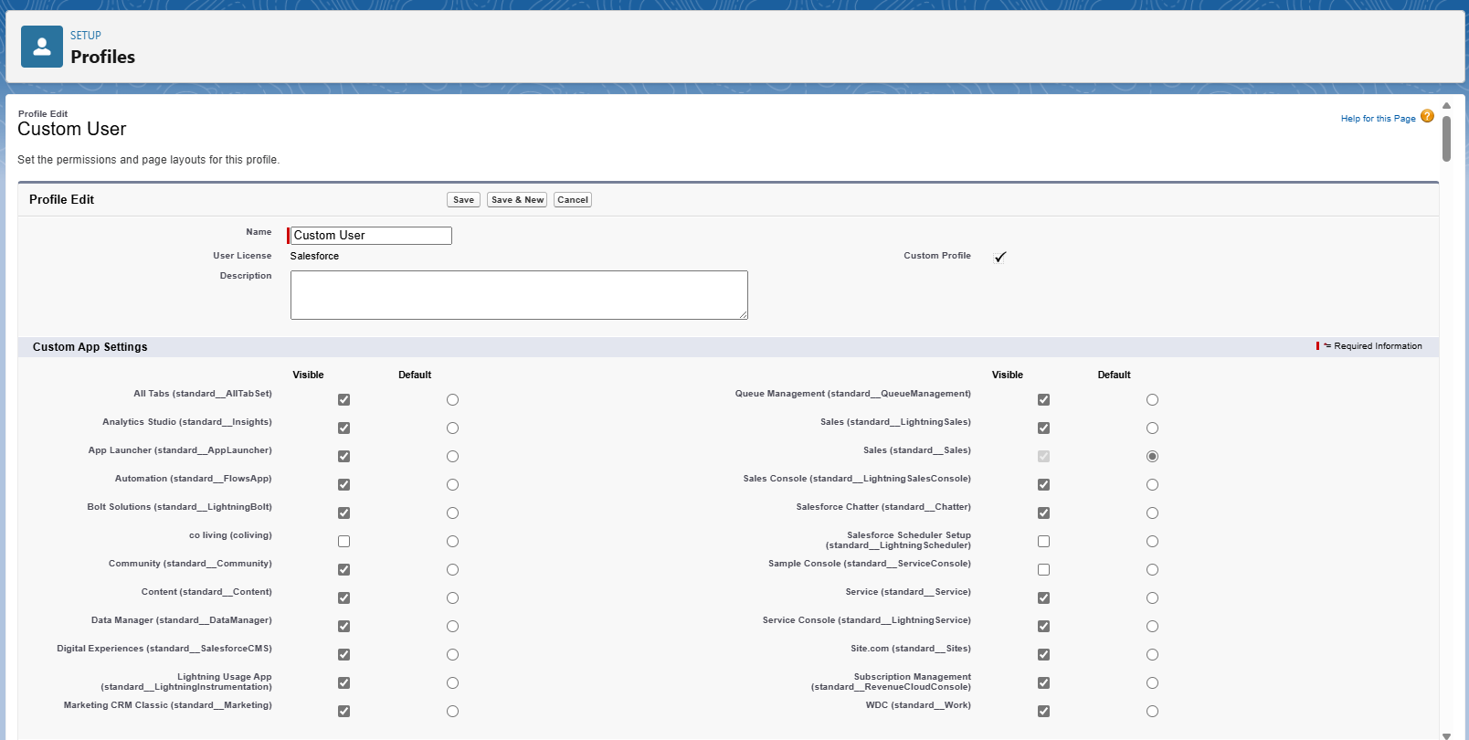

### **Custom platform user1**

1. Go to setup > type profiles in quick find box > click on profiles > clone the desired profile (Standard platform User)
2. Enter profile name (Custom platform User1) > Save.
3. While still on the profile page, then click Edit.
4. Scroll down to Custom Object Permissions and Give only Read access permissions for Customers, Feedbacks, Food selections, Payments, Room Bookings and Total Rooms.
5. Scroll down and Click on Save.

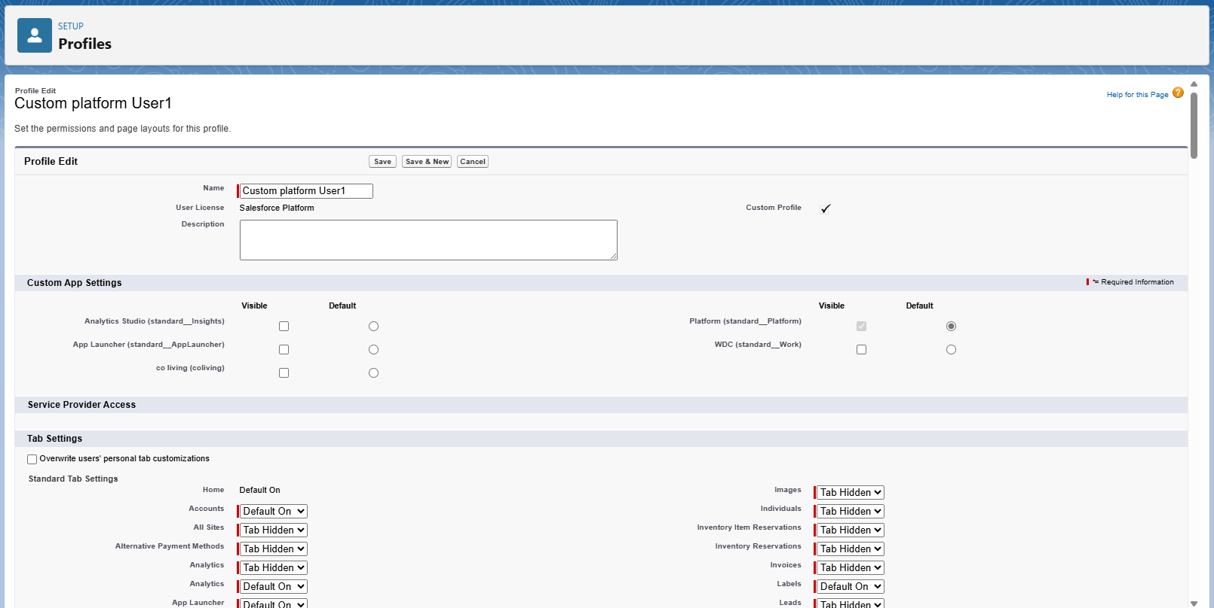

### **Custom platform user2**

1. Go to setup > type profiles in quick find box > click on profiles > clone the desired profile (Standard platform User)
2. Enter profile name (Custom platform User2) > Save.
3. While still on the profile page, then click Edit.
4. Scroll down to Custom Object Permissions and Give Create, Read, Edit and Delete access permissions for Customers, Feedbacks, Food selections, Payments and Room Bookings. And Read Access permission for Total Rooms Object.
5. Scroll down and Click on Save.

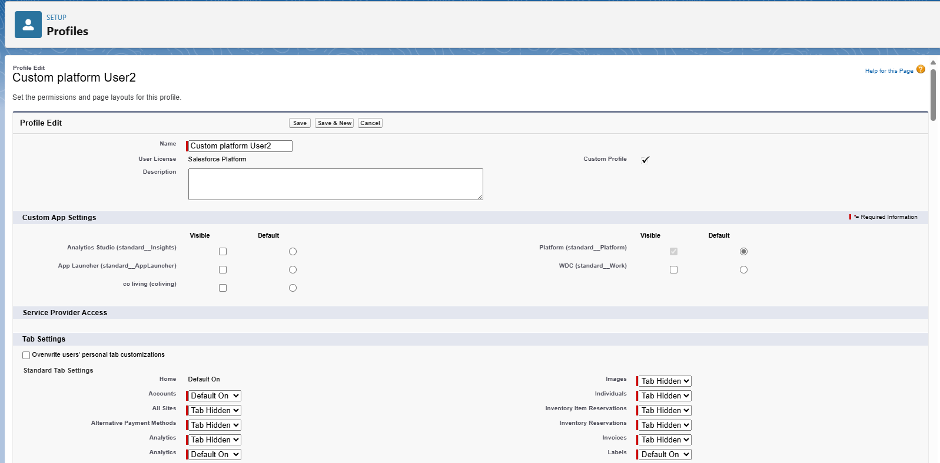

### **Task 8:Create Roles**

### Marketing Role

1.Go to quick find > Search for Roles > click on set up roles.

2.Click on Expand All and click on add role under CEO role.

3.Give Label as “Marketing” and Role name gets auto populated.

4.Then click on Save.

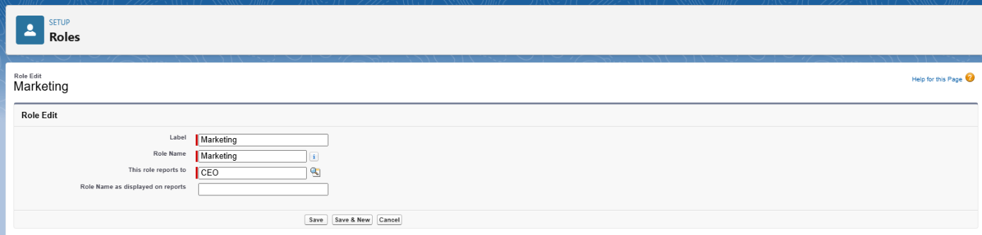

### Receptionist Role

1. Go to quick find > Search for Roles > click on set up roles.
2. Click on Expand All and click on add role under CEO role.
3. Give Label as “Receptionist” and Role name gets auto populated.

4.Then click on Save.

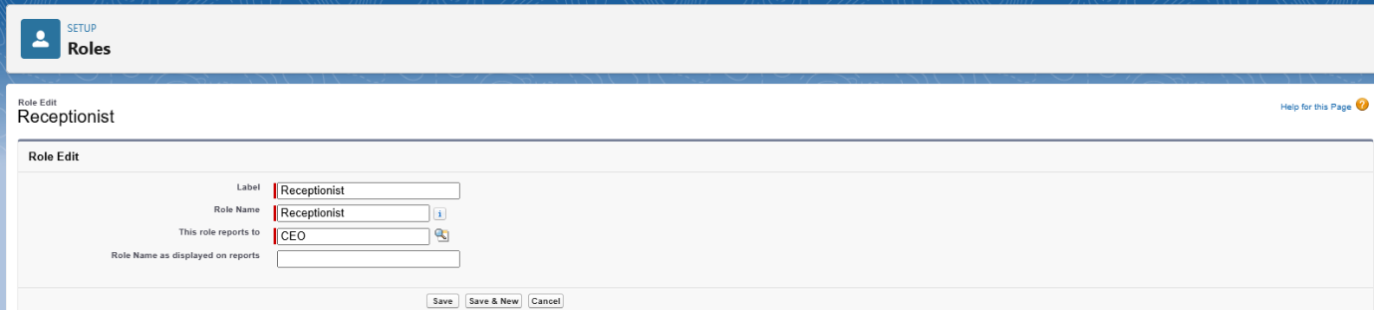

**Task 9:Create User**

### Create User

1.Go to setup > type users in quick find box > select users > click New user.

1. Fill in the fields

* First Name : sandeep
* Last Name : gujja
* Alias : Give a Alias Name
* Email id : Give your Personal Email id
* Username : Username should be in this form: text@text.com
* Nick Name : Give a Nickname
* Role   : CEO
* User licence : Salesforce
* Profiles   : Custom user

1. save.

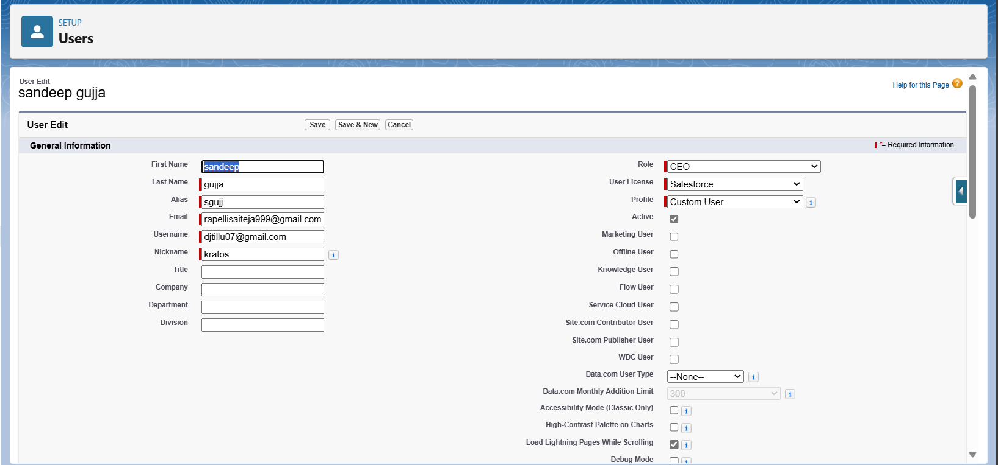

### Create Another User

1. Go to setup > type users in quick find box > select users > click New user.
2. Fill in the fields

* First Name : Abhilash
* Last Name : garapati
* Alias           : Give a Alias Name
* Email id : Give your Personal Email id
* Username : Username should be in this form: text@text.com
* Nick Name : Give a Nickname
* Role : Marketing
* User licence: Salesforce platform
* Profiles : Custom Platform User1

3.save

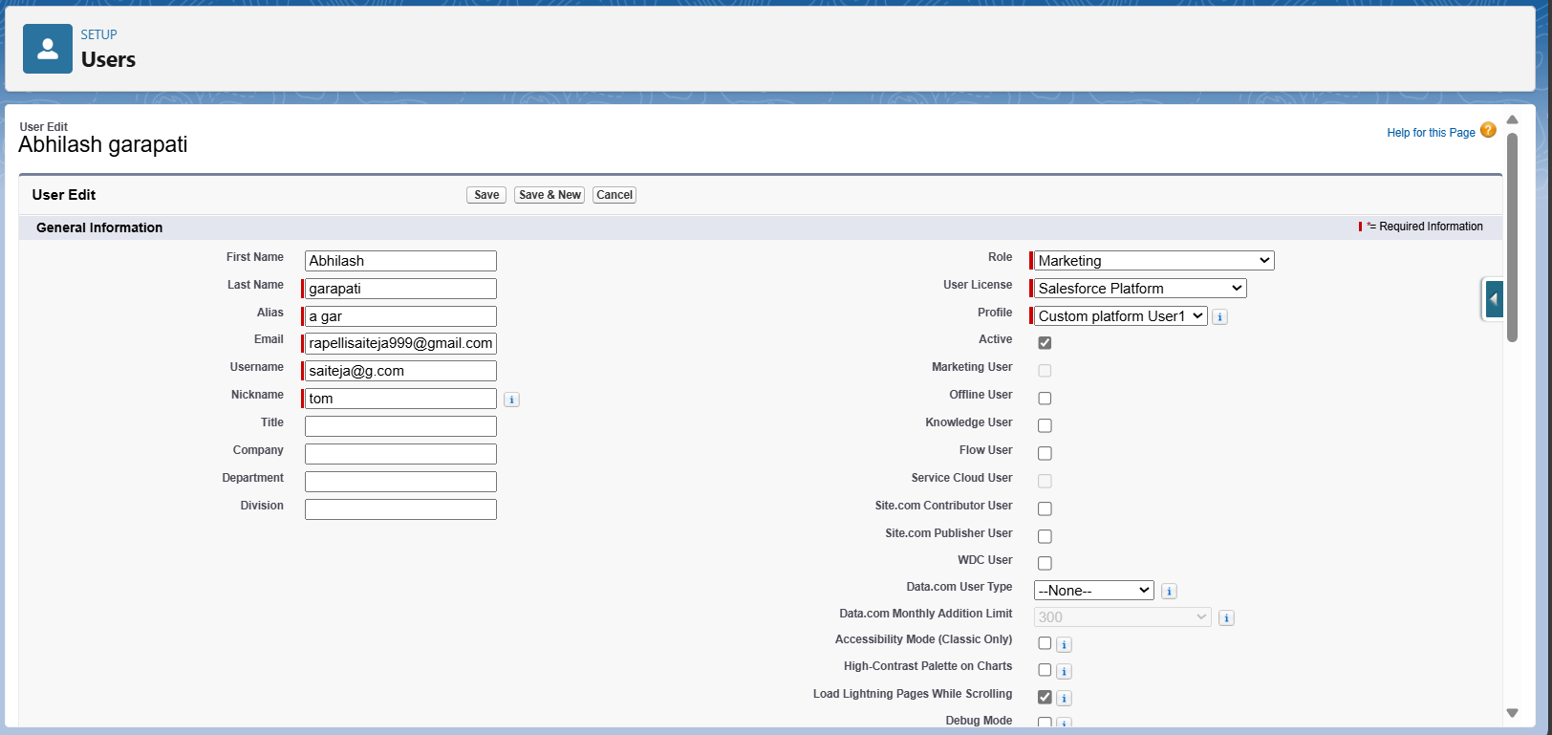

### Create Another User

1. Go to setup > type users in quick find box > select users > click New user.
2. Fill in the fields

* First Name : Ganesh
* Last Name : gelli
* Alias : Give a Alias Name
* Email id : Give your Personal Email id
* Username : Username should be in this form: text@text.com
* Nick Name: Give a Nickname
* Role : Receptionist
* User licence: Salesforce Platform
* Profiles : Custom Platform user2

1. Save

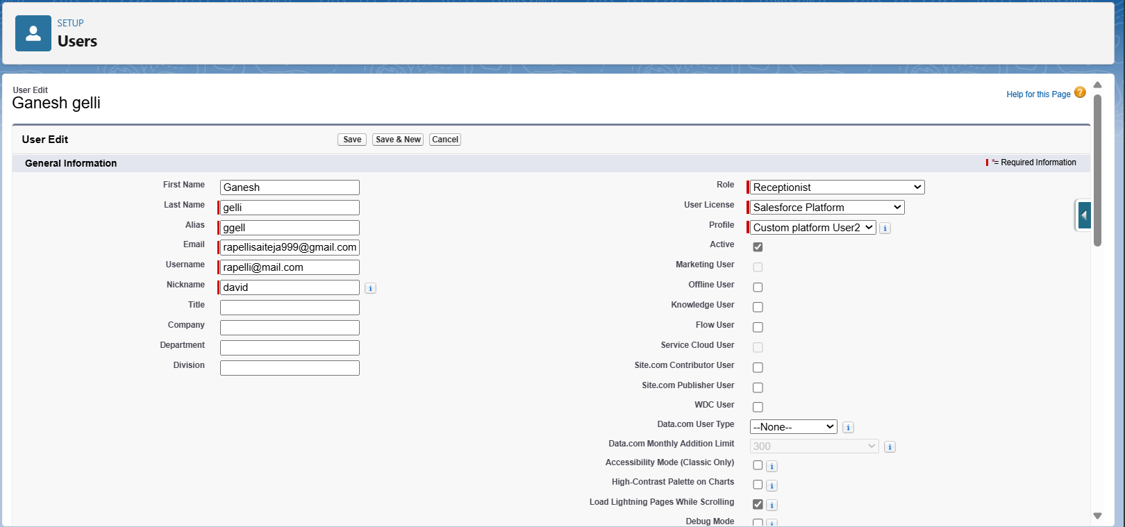

**Task 10:Create Reports**

### Create Report

1. Go to the app > click on the reports tab
2. Click New Report.
3. Select report type from category or from report type panel or from search panel “Customers with Room Bookings with Total Rooms ” > click on start report.
4. Customize your report
5. Add fields from left pane as shown below
6. Save or run it.

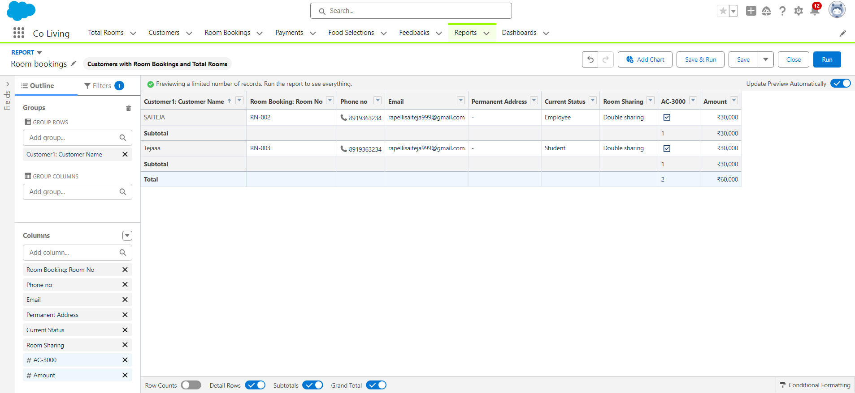

### Create another Report

1. Go to the app > click on the reports tab
2. Click New Report.
3. Select report type from category or from report type panel or from search panel Select customer with Room booking with Payments ? click on start report.
4. Customize your report
5. Add fields from left pane as shown Above
6. Save or run it.

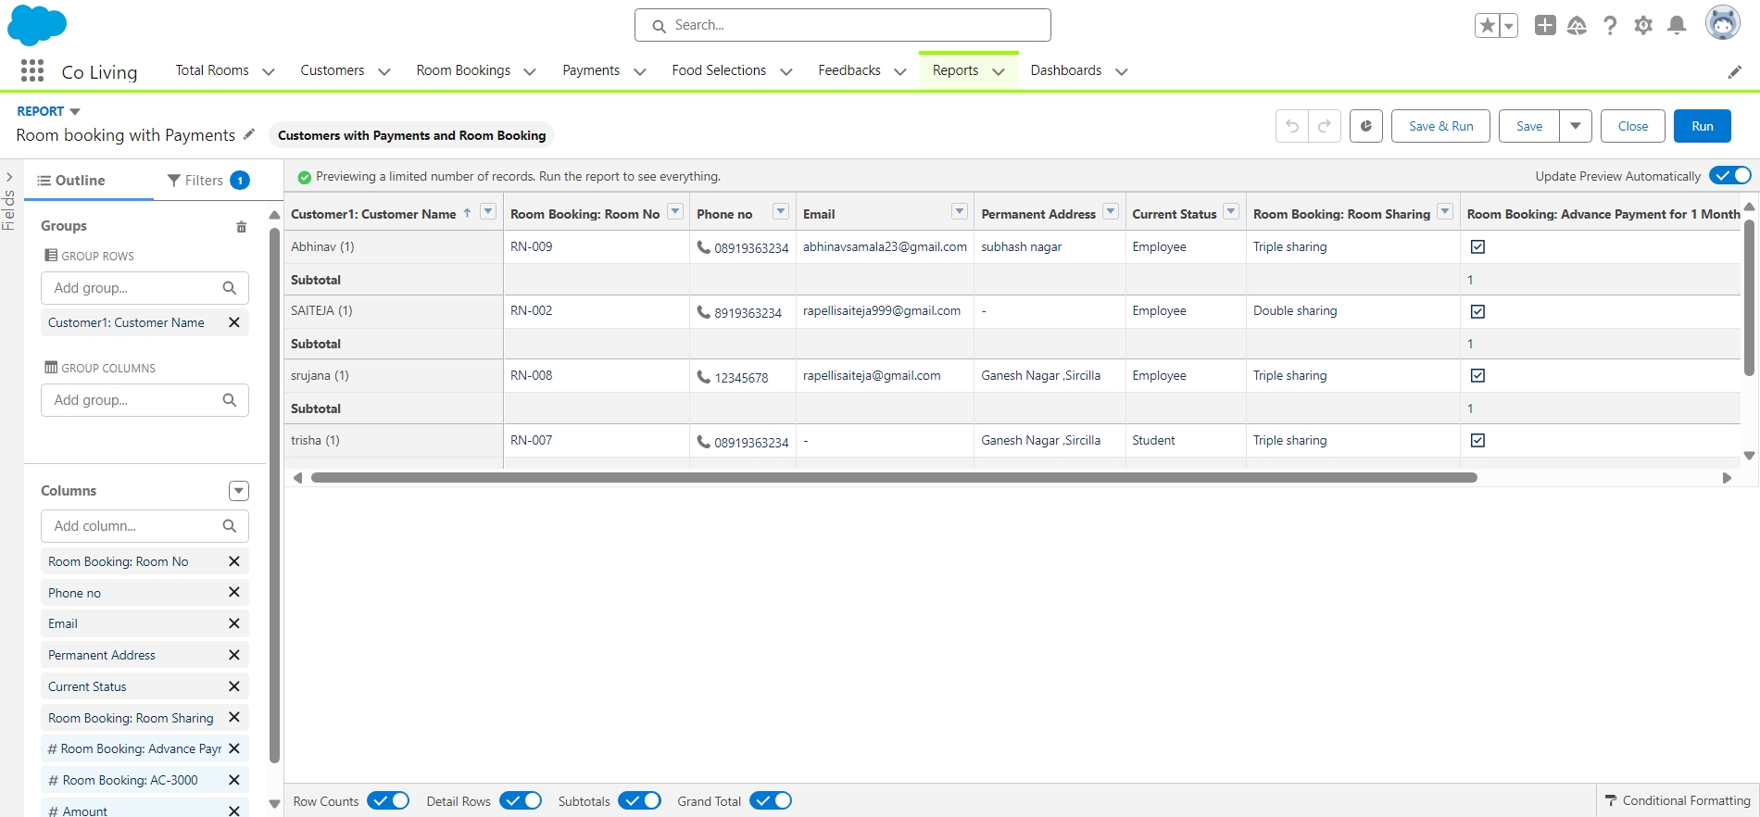

**Task 11:Dashboard creation**

### **Create Dashboard**

1. Go to the app > click on the Dashboard tabs and click on new Dashboard
2. Give a Name and click on Create.
3. Select add component.
4. Select a Report Customer with Room Booking and click on select.
5. Click Add then click on Save and then click on Done.

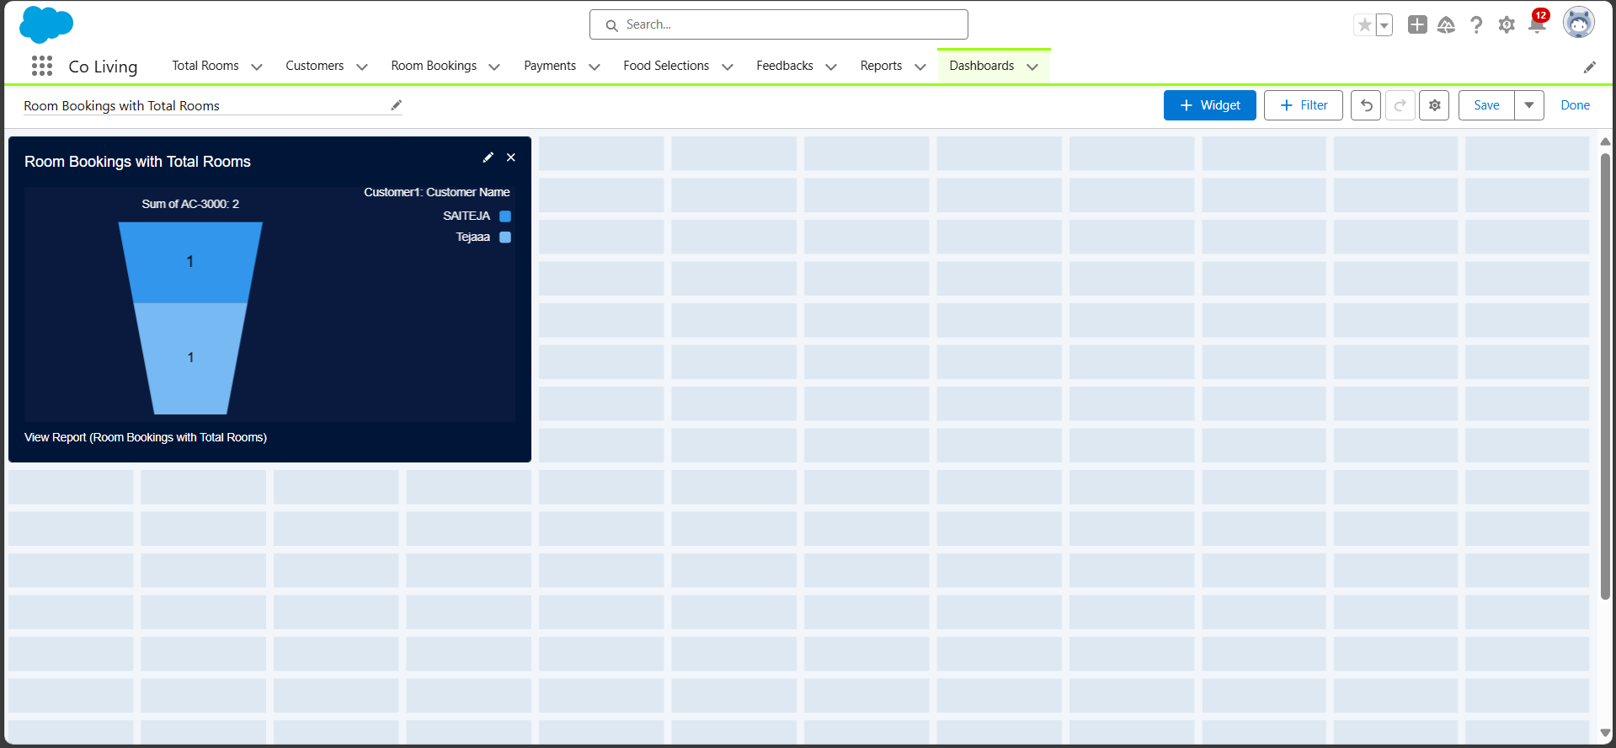

### Create Another Dashboard

1. Go to the app > click on the Dashboard tabs and click on new Dashboard.
2. Give a Name and click on Create.
3. Select add component.
4. Select a Report Customer with Room Booking with Payments and click on select.
5. Click Add then click on Save and then click on Done.

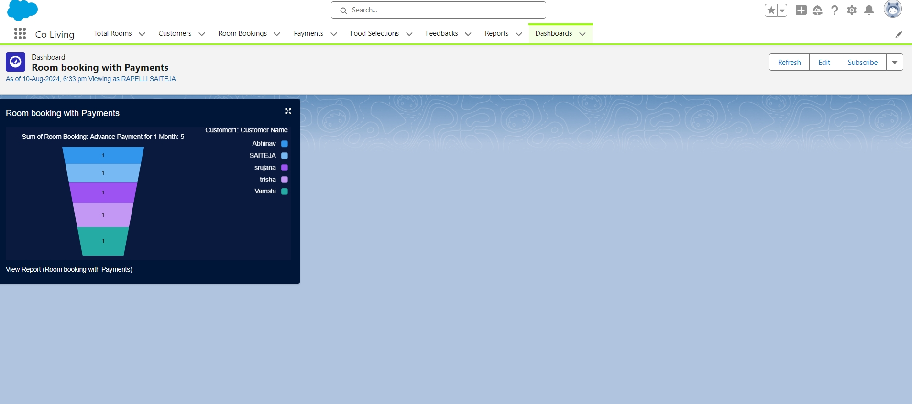

**Task 12:Create Flow**

### Create a Flow

1. Go to setup > type Flow in quick find box > Click on the Flow and Select the New Flow.
2. Select the Record-triggered flow and Click on Create.
3. Select the Object as a Room Booking in the Drop down list.
4. Select the Trigger Flow when: “A record is Created or Updated”.
5. Select the Optimize the flow for: “Actions and Related Records” and Click on Done.
6. Under the Record-triggered Flow Click on “+” Symbol and In the Drop down List select the “Decision Element”.
7. Enter the Details Label: Field should be Update, API name: Gets Automatically Generated.
8. Enter the Outcome Details Label: Single sharing, Outcome API name: Gets Automatically Generated.

* Resource: Select Record.Room sharing.
* Operator: Select Equals.
* Value: Select Single sharing.
* Click on “Add Condition”
* Resource: Select Record.AC-3000.
* Operator: Select Equals.
* Value: Select False.
* Click on “+” Symbol In the Outcome Order.

1. Enter the Outcome Details Label: Double sharing, Outcome API name: Gets Automatically Generated.

* Resource: Select Record.Room sharing.
* Operator: Select Equals.
* Value: Select Double sharing.
* Click on “Add Condition”
* Resource: Select Record.AC-3000.
* Operator: Select Equals.
* Value: Select False.
* Click on “+” Symbol In the Outcome Order.

1. Enter the Outcome Details Label: Triple sharing, Outcome API name: Gets Automatically Generated.

* Resource: Select Record.Room sharing.
* Operator: Select Equals.
* Value: Select Triple sharing.
* Click on “Add Condition”
* Resource: Select Record.AC-3000.
* Operator: Select Equals.
* Value: Select False.
* Click on “+” Symbol In the Outcome Order.

1. Enter the Outcome Details Label: Single Ac, Outcome API name: Gets Automatically Generated.

* Resource: Select Record.Room sharing.
* Operator: Select Equals.
* Value: Select Single sharing.
* Click on “Add Condition”
* Resource: Select Record.AC-3000.
* Operator: Select Equals.
* Value: Select True.
* Click on “+” Symbol In the Outcome Order.

1. Enter the Outcome Details Label: Double Ac, Outcome API name: Gets Automatically Generated.

* Resource: Select Record.Room sharing.
* Operator: Select Equals.
* Value: Select Double sharing.
* Click on “Add Condition”
* Resource: Select Record.AC-3000.
* Operator: Select Equals.
* Value: Select True.
* Click on “+” Symbol In the Outcome Order.

1. Enter the Outcome Details Label: Triple Ac, Outcome API name: Gets Automatically Generated.

* Resource: Select Record.Room sharing.
* Operator: Select Equals.
* Value: Select Triple sharing.
* Click on “Add Condition”
* Resource: Select Record.AC-3000.
* Operator: Select Equals.
* Value: Select True.
* Click on Done.

1. Click on “+” Symbol under the single sharing and Select the “update Records" in the drop down list.
2. Enter the update records details

* Label: Single.
* API name: Gets automatically Generated.
* Under the Set Field Values for the Room Booking Record.
* Field: Amount.
* Value: 28000.
* Click on Done.

1. Enter the update records details

* Label: Double.
* API name: Gets automatically Generated.
* Under the Set Field Values for the Room Booking Record.
* Field: Amount.
* Value: 24000.
* Click on Done.

1. Enter the update records details

* Label: Triple.
* API name: Gets automatically Generated.
* Under the Set Field Values for the Room Booking Record.
* Field: Amount.
* Value: 20000.
* Click on Done.

1. Enter the update records details

* Label: Single ac1.
* API name: Gets automatically Generated.
* Under the Set Field Values for the Room Booking Record.
* Field: Amount.
* Value: 34000.
* Click on Done.

1. Enter the update records details

* Label: Double ac1.
* API name: Gets automatically Generated.
* Under the Set Field Values for the Room Booking Record.
* Field: Amount.
* Value: 30000.
* Click on Done.

1. Enter the update records details

* Label: Triple ac1.
* API name: Gets automatically Generated.
* Under the Set Field Values for the Room Booking Record.
* Field: Amount.
* Value: 26000.
* Click on Done.

1. The Flow will Form like This and Click on save.
2. Enter the Flow Label: Update Amount Field, Flow API Name: Gets Automatically Generated and Click on Save.

